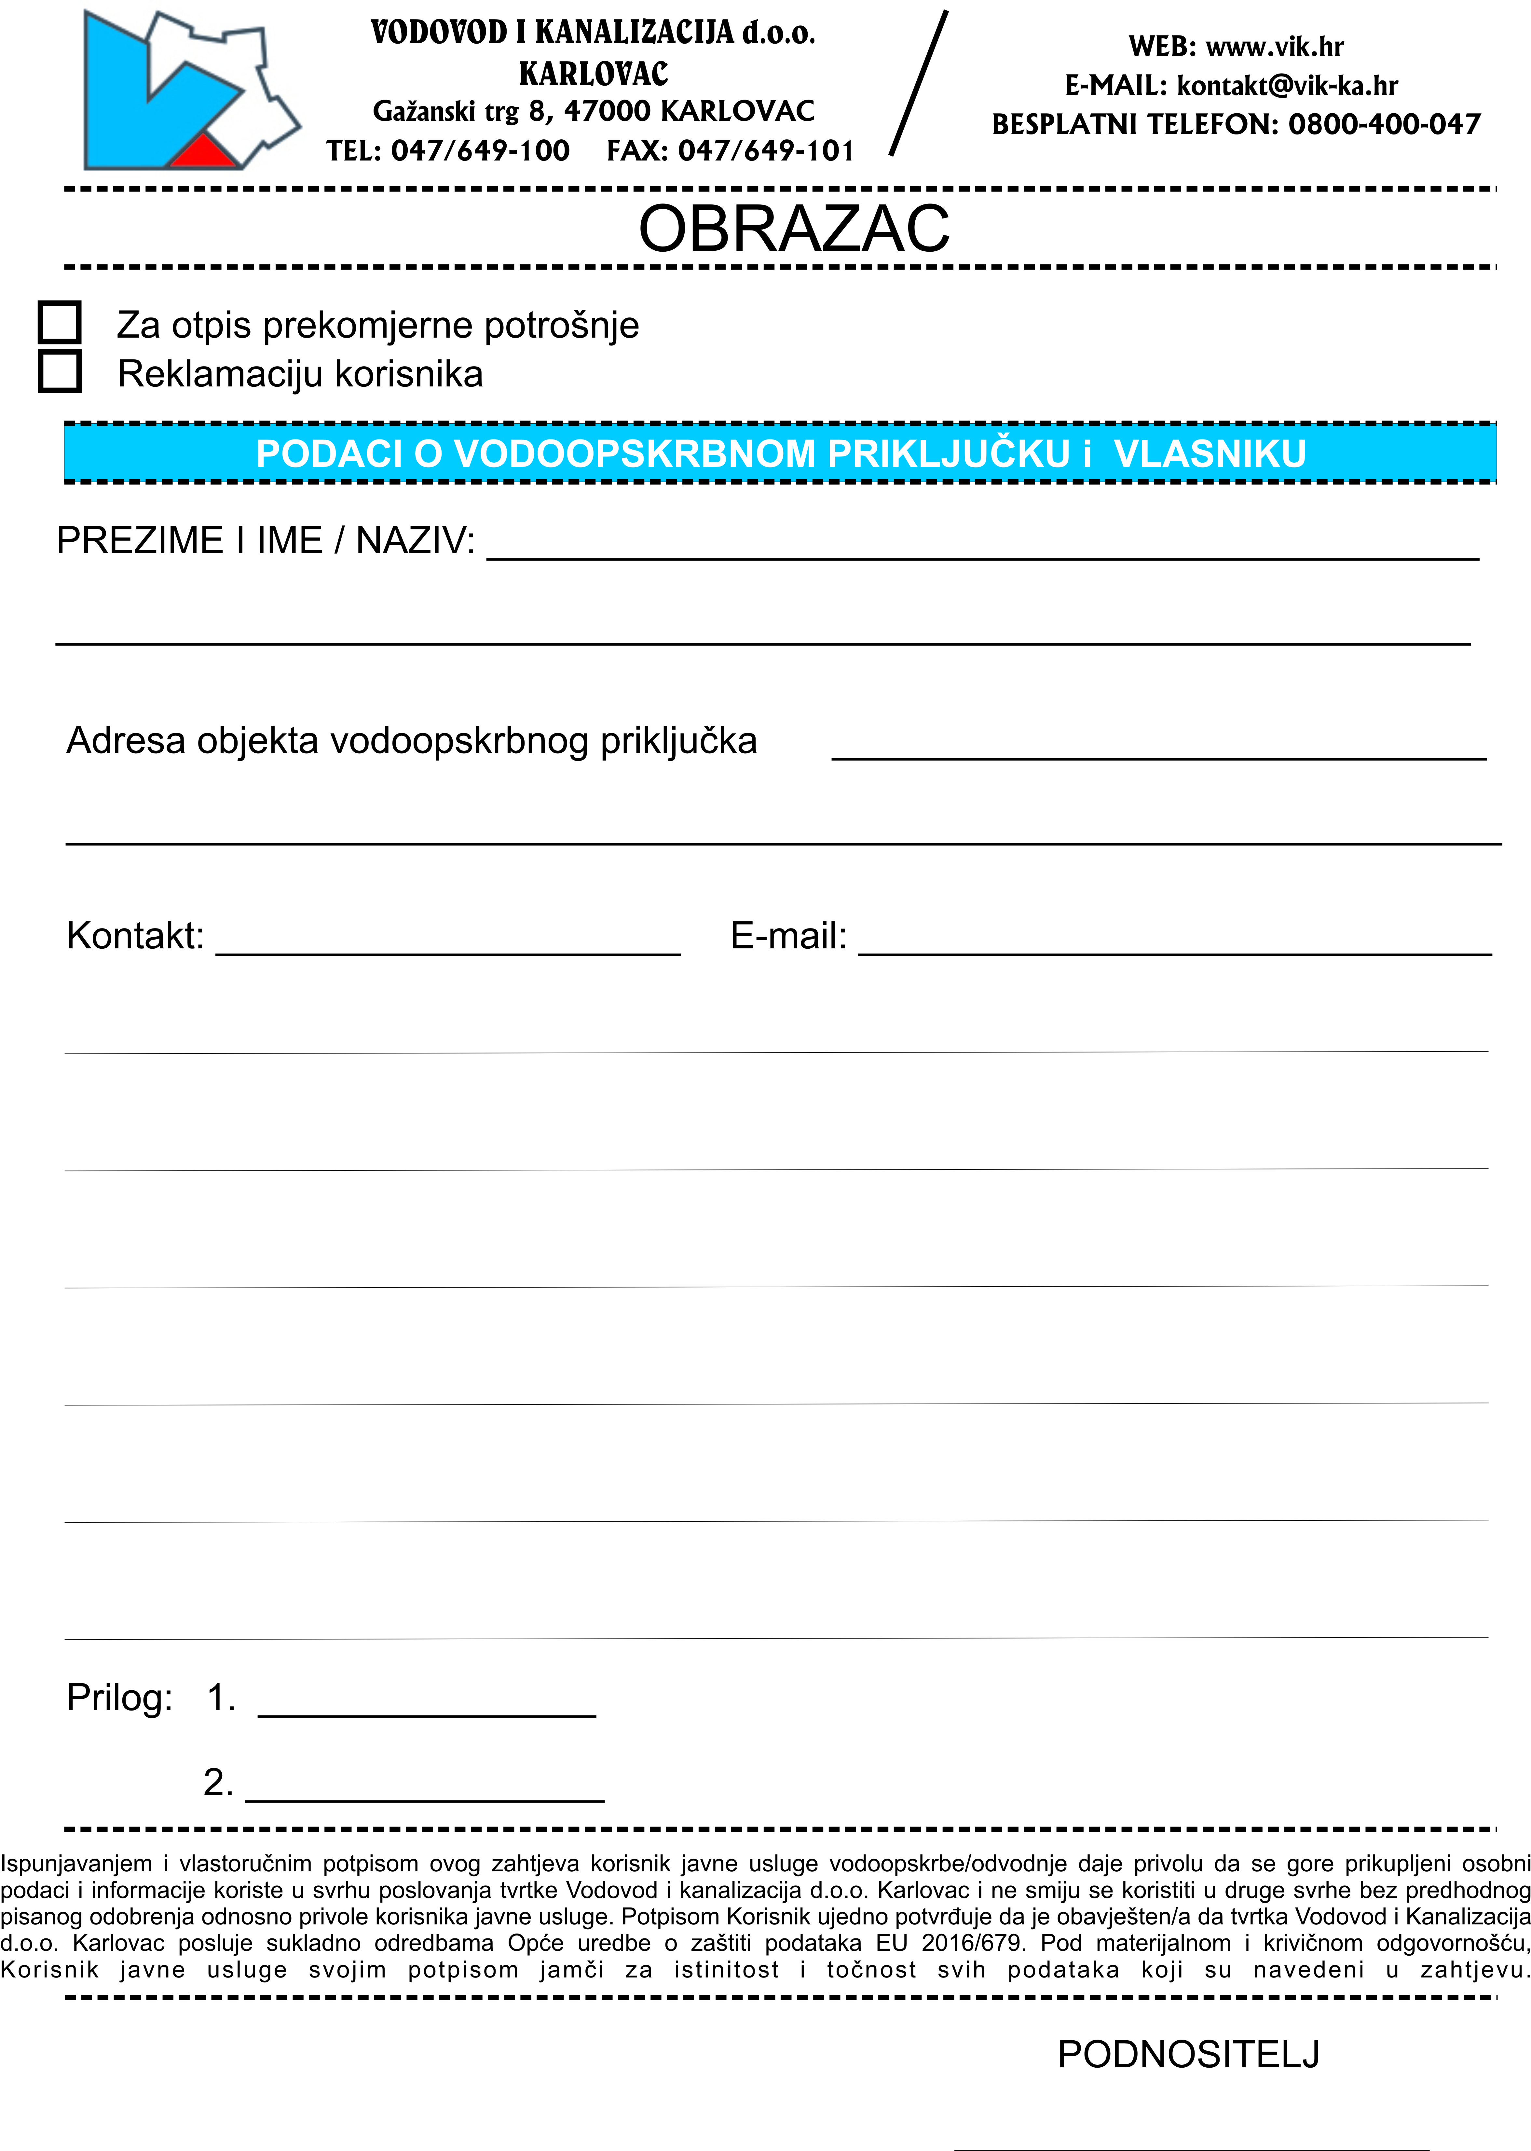

Karlovac, __________________